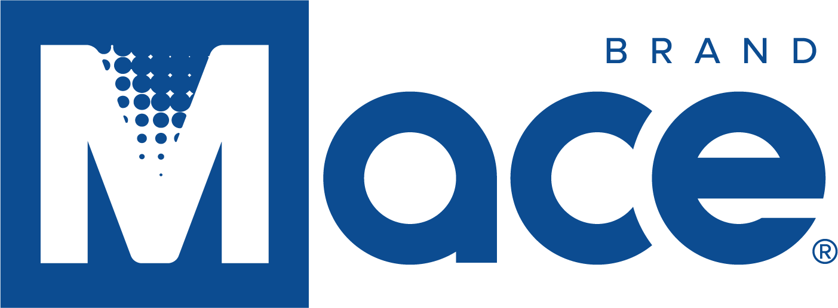

Mace Announces its Participation in the Fourth Quarter 2021 Investor Summit

CLEVELAND, Ohio, November 11, 2021 – Mace® Security International, Inc. (OTCQX: MACE), a globally recognized leader in personal safety products, is pleased to announce its participation in the Investor Summit (virtual) scheduled for Wednesday, November 17th at 10:15 AM (EST). Please see registration links below.

This will be a live, interactive online event where investors are invited to ask the company questions in real-time. If attendees are not able to join the event live on the day of the conference, an archived webcast will also be made available after the event.

It is recommended that investors pre-register and run the online system check to expedite participation and receive event updates.

Learn more about the event and register at: Attendee Information or
https://www.meetmax.com/sched/event_74761/investor_reg_new.html

About Mace® Security International, Inc.:
Mace® Security International, Inc. (MACE) is a globally recognized leader in personal safety and security. Based in Cleveland, Ohio, the company has spent more than 40 years designing and manufacturing consumer and tactical products for personal defense and security under its world-renowned Mace® Brand – the original trusted brand of defense spray products. The company also offers aerosol defense sprays and tactical products for law enforcement and security professionals worldwide through its Mace® Take Down® brand, KUROS!® Brand personal safety products, Vigilant® Brand alarms, and Tornado® Brand pepper spray and stun guns. MACE® distributes and supports Mace® Brand products through mass market retailers, wholesale distributors, independent dealers, Amazon.com, Mace.com, and other channels. For more information, visit www.mace.com.

Contact:
Mike Weisbarth
Chief Financial Officer
mweisbarth@mace.com

