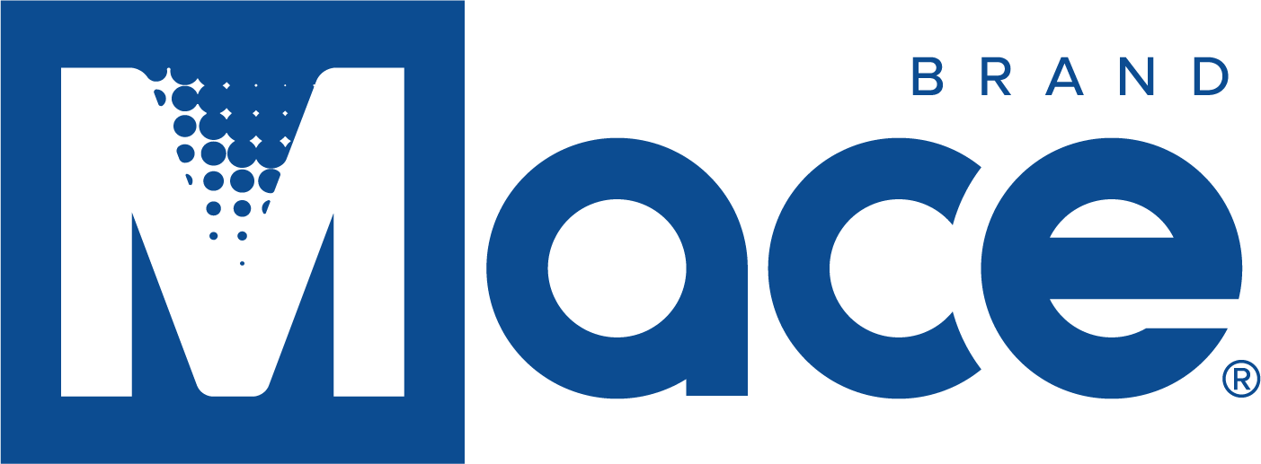

Mace Security International, Inc. extends its Revolving Credit Agreement

CLEVELAND, Ohio, August 1, 2022 – Mace® Security International, Inc. (OTCQX: MACE), a globally recognized leader in personal safety products, announces that it has extended its Revolving Line of Credit with Fifth Third Bank National Association (“the Credit Agreement”) effective July 29, 2022. The Credit Agreement is secured by substantially all Company assets and matures on May 30, 2023. The Credit Agreement provides for monthly interest payments at a floating rate per annum equal to the SOFR plus 2.00% through and including November 30, 2022 and 2.50% from and after December 1, 2022.

Sanjay Singh, Chairman and CEO commented “The early extension of an additional six months to its existing line of credit aids the value maximization being pursued by Mace’s board of directors. This extension provides working capital for the various revenue generating opportunities that the company is pursuing in the back half of 2022 and first half of 2023”.

About Mace® Security International, Inc.:
Mace® Security International, Inc. (MACE) is a globally recognized leader in personal safety and security. Based in Cleveland, Ohio, the company has spent more than 40 years designing and manufacturing consumer and tactical products for personal defense and security under its world-renowned Mace® Brand – the original trusted brand of defense spray products. The company also offers aerosol defense sprays and tactical products for law enforcement and security professionals worldwide through its Mace® Take Down® brand, KUROS!® Brand personal safety products, Vigilant® Brand alarms, and Tornado® Brand pepper spray and stun guns. MACE® distributes and supports Mace® Brand products through mass market retailers, wholesale distributors, independent dealers, Amazon.com, Mace.com, and other channels. For more information, visit www.mace.com.

Contact:
Mark O’Conner
Corporate Controller
Mo’conner@mace.com

